July 2022

Dear Friend of the Festival:

Greetings to you from the planning committee for the 2022 Lutheran Hymn Festival. Under the theme, “O Love, How Deep, How Broad, How High” we will share the blessing of our 11th festival on September 18, 4:30 p.m. (our 1st afternoon matinee) at the Morton H. Meyerson Symphony Center in Dallas. Our festival will be led by guest organist Kantor Kevin Hildebrand with support from brass, tympani, adult and children choirs.

We humbly ask you to be our advocate for this festival and help us advertise in your church or workplace. Please make sure that the bulletin inserts will be in the worship bulletin for at least 3 Sundays. We had a complete sell-out crowd in 2016, so advertising early will be very important.

Enclosed you will find a bulletin insert and bulletin articles to assist you in publicizing this event. Electronic versions are available at: www.lutheranhymnfestival.org/resources .

Details for the festival include:

- DATE, TIME: September 18, 4:30 p.m. (NOTE: first time for an afternoon matinee)

- LOCATION: Morton H. Meyerson Symphony Center, Dallas

- TICKET PRICES: 1st Floor, Orchestra terrace, 3rd & 4th Floor boxes: $20.00 each
Dress Circle & Grand Tier: $15.00 each

- PURCHASING TICKETS: Tickets will only be available through an On-Line purchase. Please go to www.lutheranhymnfestival.org/tickets. Patrons should BRING THEIR PRINTED TICKET(S) TO THE MEYERSON.

- FOR BLOCK SEATING: The easiest method to guarantee a group from your church will sit together, is for someone to coordinate the sale by having members send their checks either to church or to the individual. The individual then goes On-Line to make the seat selections and purchase the tickets. But, remember, each person must BRING THEIR PRINTED TICKET TO THE MEYERSON.

- FOR QUESTIONS OR INFORMATION: Contact Adam Hengeveld at 972-646-0905 (leave a message if I am unavailable) or tickets@lutheranhymnfestival.org.

May our Lord be praised through this festive event.

Sincerely,
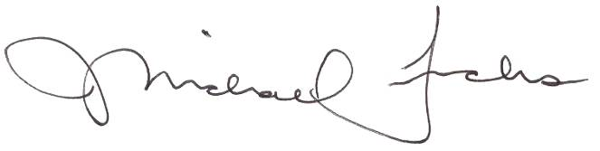
Adam Hengeveld, Ticket Sales Chair

www.lutheranhymnfestival.org/tickets

